EAST WEST UNIVERSITY — Department of CSE
CSE303: Statistics for Data Science — Mini Project Report, Summer 2026
Sleep Disorder Prediction from Lifestyle and Physiological Indicators: A Classification Approach
Submitted By:  Md Radowan Ahmed — 2024-3-60-464  Shahriar Rahman — 2022-3-60-036  Juboraj Podder — 2023-2-60-048 | Submitted To:  Dr. Nafis Sadeq  Assistant Professor  Department of CSE

Abstract — This report investigates whether a person's sleep-disorder status can be predicted from everyday lifestyle and physiological indicators using a 400-record survey dataset. After exploratory analysis and preprocessing (one-hot encoding, SMOTE oversampling for class imbalance), three classifiers — Logistic Regression, Decision Tree, and Random Forest — were trained and compared against a majority-class baseline. Random Forest reached the highest test accuracy (77.5%), while Decision Tree gave more balanced performance across the minority classes. The results highlight both the potential and the limits of lifestyle-only predictors for a clinically imbalanced, modestly sized dataset.

1. Introduction and Motivation
Sleep disorders such as insomnia and sleep apnea are widespread and are closely tied to everyday lifestyle and physiological factors, including stress, physical activity, and body-weight category. Understanding which of these factors relate most strongly to sleep problems can support early screening before a clinical diagnosis is made. This project uses a lifestyle and health survey dataset to explore these relationships statistically and to build a classifier that predicts a person's sleep-disorder status.

2. Research Question
Can a person's sleep disorder status (none, insomnia, or sleep apnea) be predicted from lifestyle and physiological indicators such as age, occupation, stress level, physical activity, BMI category, blood pressure, heart rate, and daily steps, and which of these factors are most strongly associated with sleep outcomes?

3. Dataset and Target-Label Construction
The dataset contains 400 individual records with 13 attributes: Person ID, Gender, Age, Occupation, Sleep Duration, Quality of Sleep, Physical Activity Level, Stress Level, BMI Category, Blood Pressure, Heart Rate, Daily Steps, and Sleep Disorder. The target variable, Sleep Disorder, originally contained missing values for individuals without a diagnosed condition; these were filled with the explicit label "No Sleep Disorder" rather than dropped, since a missing entry represents a clinically meaningful class rather than an unknown value. The resulting three-class target is imbalanced: No Sleep Disorder (72.5%), Insomnia (19.75%), and Sleep Apnea (7.75%).

4. Exploratory Data Analysis
Descriptive statistics and visualizations were used to inspect the data before modeling. The dataset has no missing values after label construction, and numeric variables (Age, Sleep Duration, Physical Activity Level, Stress Level, Heart Rate, Daily Steps) were checked for range and outliers using describe() and boxplots.
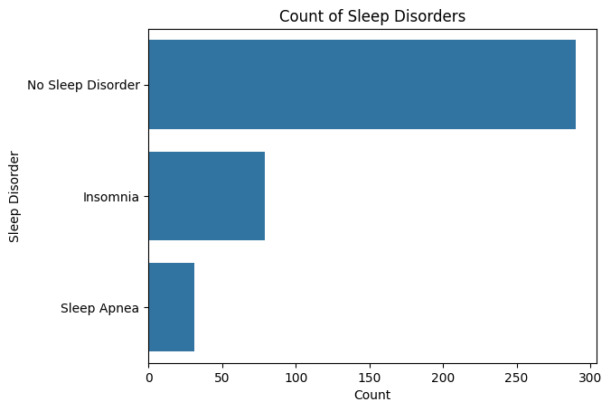
Figure 1. Class distribution of the Sleep Disorder target, showing the imbalance toward 'No Sleep Disorder'.
A correlation heatmap (Figure 2) was used to examine linear relationships among numeric features. Sleep Duration and Quality of Sleep showed essentially no linear correlation (r ≈ -0.002) in this sample, suggesting that sleep quality depends on factors other than duration alone, such as stress or activity level.
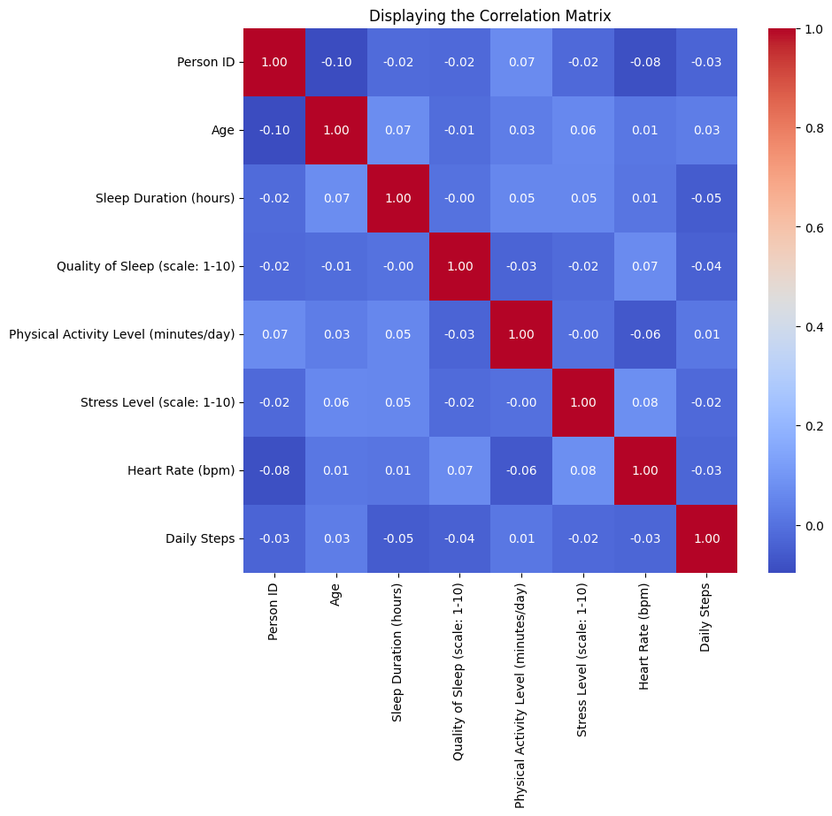
Figure 2. Correlation matrix of numeric lifestyle and physiological variables.
Quality of Sleep was also compared across occupation groups using boxplots (Figure 3), revealing visible differences in median sleep quality between occupations such as Retired, Student, and Office Worker, motivating Occupation as a candidate predictor.
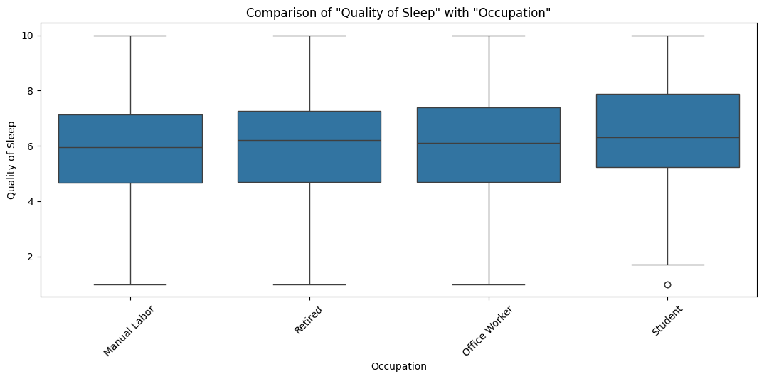
Figure 3. Quality of Sleep across occupation groups.
The sample's gender split and the relationship between Sleep Duration and Quality of Sleep were also examined directly (Figure 5, Figure 6) to check for obvious sampling bias and to visualize the near-zero correlation reported above at the record level rather than only as a single coefficient.
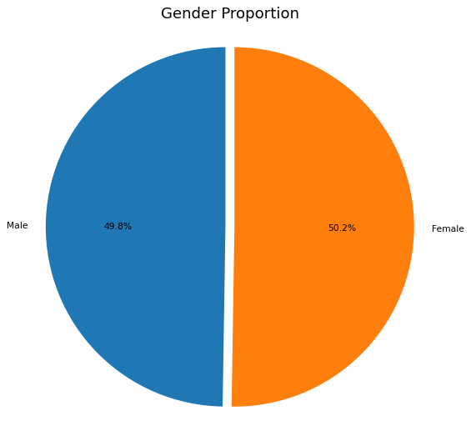
Figure 5. Proportion of male and female participants in the dataset.
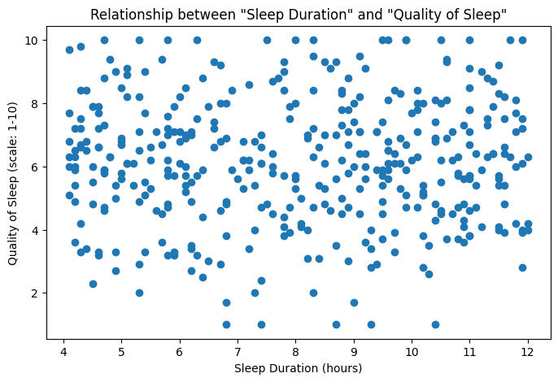
Figure 6. Sleep Duration versus Quality of Sleep at the individual-record level.
Sleep Disorder prevalence was also broken down by Gender (Figure 7); both Insomnia and Sleep Apnea appear in both gender groups, so Gender alone does not separate the classes and was kept only as one input among several rather than a primary predictor.
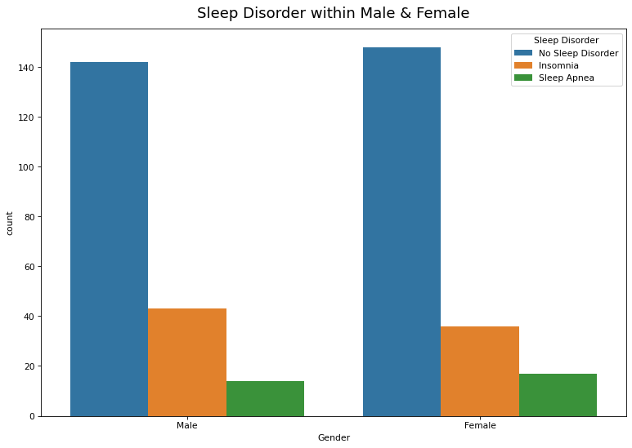
Figure 7. Sleep Disorder counts split by Gender.

5. Methodology
Preprocessing
Numeric features (Age, Sleep Duration, Physical Activity Level, Stress Level, Heart Rate, Daily Steps) were passed through unchanged, while categorical features (Gender, Occupation, BMI Category, Blood Pressure) were one-hot encoded. Because the target classes are imbalanced, SMOTE (Synthetic Minority Over-sampling Technique) was applied to the training data only, inside the modeling pipeline, so that the minority classes (Insomnia, Sleep Apnea) were not overwhelmed by the majority class during training.
Feature summary
- Numeric: Age (years), Sleep Duration (hours), Quality of Sleep (1–10 scale), Physical Activity Level (minutes/day), Stress Level (1–10 scale), Heart Rate (bpm), Daily Steps.
- Categorical: Gender, Occupation, BMI Category (Normal / Overweight / Obese), Blood Pressure (systolic/diastolic reading, treated as a category).
- Identifier (dropped before modeling): Person ID.
- Target: Sleep Disorder — No Sleep Disorder / Insomnia / Sleep Apnea.
Baseline models
Two baselines were used: (1) a majority-class baseline that always predicts "No Sleep Disorder", giving an accuracy equal to the class proportion (72.5%) but zero recall on the minority classes; and (2) Logistic Regression, a simple linear classifier, as a baseline learning algorithm.
Proposed model
A Random Forest classifier (50 trees) was selected as the proposed model because ensemble tree methods handle non-linear feature interactions and mixed categorical/numeric data well, and combine naturally with SMOTE inside a single pipeline. A Decision Tree was also trained as a simpler tree-based comparison point.

6. Experimental Setup
The data were split into 80% training and 20% testing (test size = 0.2, random_state = 99), giving 320 training and 80 testing records. Model performance was further validated with 10-fold cross-validation on the training set. All models were evaluated using accuracy, per-class precision/recall/F1-score, and the confusion matrix, since accuracy alone is misleading on an imbalanced target.

7. Results
Table 1 summarizes test-set performance. Random Forest achieved the highest overall accuracy (77.5%), while the Decision Tree achieved a higher macro-averaged F1-score (0.48) than Random Forest (0.34), indicating it performed more evenly across the minority classes despite a slightly lower accuracy. Logistic Regression performed worst overall (47.5% accuracy), suggesting the relationship between features and sleep disorder is not well captured by a linear decision boundary. *Baseline macro/weighted F1 values are computed assuming the model only ever predicts the majority class.
Table 1. Test-set performance comparison across models.
Model | Accuracy | Macro F1 | Weighted F1
Majority-class baseline | 72.5% | 0.28* | 0.61*
Logistic Regression | 47.5% | 0.25 | 0.56
Decision Tree | 76.25% | 0.41 | 0.75
Random Forest (proposed) | 77.5% | 0.34 | 0.73
The Random Forest confusion matrix (Figure 4) shows that the model predicts "No Sleep Disorder" reliably (61 of 65 correctly classified) but struggles to separate Insomnia and Sleep Apnea from the majority class, which is the expected effect of severe class imbalance even after SMOTE resampling of the training data.
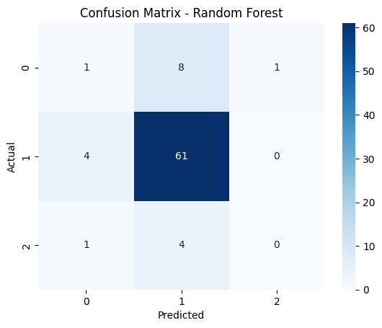
Figure 4. Confusion matrix for the proposed Random Forest model on the test set.
For comparison, the confusion matrices for Logistic Regression and Decision Tree are shown in Figures 8 and 9. Logistic Regression misclassifies far more "No Sleep Disorder" cases than the tree-based models, consistent with its low overall accuracy, while the Decision Tree spreads its errors more evenly across classes, which explains its higher macro F1-score despite lower raw accuracy than Random Forest.
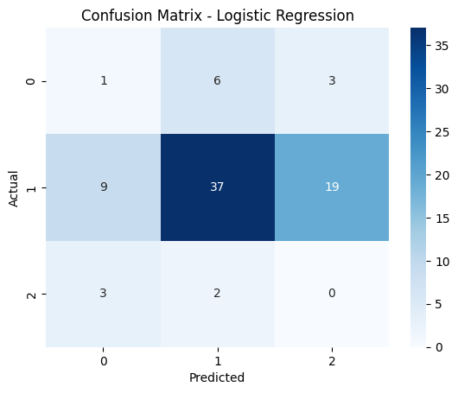
Figure 8. Confusion matrix for the Logistic Regression baseline on the test set.
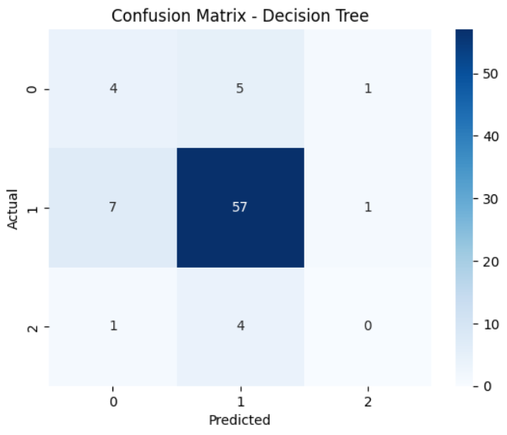
Figure 9. Confusion matrix for the Decision Tree model on the test set.
10-fold cross-validation on the training set (Table 2) confirms the same ranking seen on the held-out test set: Random Forest has the highest mean cross-validation accuracy (67.5% ± 5.1%), Decision Tree is close behind (62.5% ± 6.6%), and Logistic Regression trails clearly (42.8% ± 6.4%), giving more confidence that the test-set results are not an artifact of a single train/test split.
Table 2. 10-fold cross-validation accuracy on the training set (mean ± population std. dev.).
Model | CV Accuracy
Logistic Regression | 42.8% ± 6.4%
Decision Tree | 62.5% ± 6.6%
Random Forest (proposed) | 67.5% ± 5.1%

8. Limitations
- Sample size is modest (400 records, 80 in the test set), so minority-class metrics (Insomnia, Sleep Apnea) are estimated from very few examples and have high variance.
- Class imbalance remains a challenge even with SMOTE; recall on Sleep Apnea in particular stayed low across all models.
- Only classification was performed; formal hypothesis tests (e.g., ANOVA on sleep quality across occupations) and regression on continuous sleep outcomes were not carried out but would strengthen the statistical analysis.
- The dataset is cross-sectional survey data, so associations found do not imply causation between lifestyle factors and sleep disorders.
- Hyperparameters for all three models were left largely at library defaults (e.g., 50 trees for Random Forest); no systematic grid search or hyperparameter tuning was performed, so reported results represent a lower bound on achievable performance.
- Cross-validation accuracy (Table 2) is consistently lower than the single test-set accuracy in Table 1 for every model, showing that the 80/20 split used for Table 1 was somewhat favorable; the cross-validated numbers are the more reliable estimate of general performance.

9. Conclusion
Lifestyle and physiological indicators carry some predictive signal for sleep-disorder status: a Random Forest classifier reached 77.5% test accuracy, and a Decision Tree gave more balanced performance across classes. However, class imbalance limits reliable detection of Insomnia and Sleep Apnea, and future work should incorporate class-imbalance-aware evaluation metrics, additional data, and formal statistical hypothesis testing to confirm which lifestyle factors are significantly associated with sleep disorders.
Future Work
Beyond the limitations above, three extensions would strengthen this work: (1) running formal hypothesis tests (one-way ANOVA or Kruskal-Wallis) to statistically confirm whether Sleep Quality differs significantly across Occupation groups, rather than relying on the visual comparison in Figure 3; (2) framing a secondary regression task to predict continuous Sleep Duration or Quality of Sleep scores, evaluated with RMSE/MAE, alongside the classification task; and (3) tuning model hyperparameters (e.g., number of trees, tree depth, regularization strength) via cross-validated grid search rather than using library defaults, which could close some of the gap between the cross-validated and single-split accuracy noted above.

10. References
[1] Sleep Health and Lifestyle Dataset , provided course dataset, East West University, CSE303, Summer 2026.
[2] Pedregosa, F. et al. "Scikit-learn: Machine Learning in Python." Journal of Machine Learning Research, 2011.
[3] Lemaître, G., Nogueira, F., Aridas, C. "Imbalanced-learn: A Python Toolbox to Tackle the Curse of Imbalanced Datasets in Machine Learning." JMLR, 2017. (SMOTE implementation.)
[4] Hunter, J.D. "Matplotlib: A 2D Graphics Environment"; Waskom, M. "seaborn: statistical data visualization", JOSS, 2021.
[5] Breiman, L. "Random Forests." Machine Learning, 45(1), 5–32, 2001.
[6] Chawla, N.V., Bowyer, K.W., Hall, L.O., Kegelmeyer, W.P. "SMOTE: Synthetic Minority Over-sampling Technique." Journal of Artificial Intelligence Research, 16, 321–357, 2002.
[7] Quinlan, J.R. "Induction of Decision Trees." Machine Learning, 1(1), 81–106, 1986.
[8] Cox, D.R. "The Regression Analysis of Binary Sequences." Journal of the Royal Statistical Society, Series B, 20(2), 215–242, 1958.
[9] McKinney, W. "Data Structures for Statistical Computing in Python." Proceedings of the 9th Python in Science Conference (SciPy), 56–61, 2010.
[10] Harris, C.R. et al. "Array Programming with NumPy." Nature, 585, 357–362, 2020.
[11] Buda, M., Maki, A., Mazurowski, M.A. "A Systematic Study of the Class Imbalance Problem in Convolutional Neural Networks." Neural Networks, 106, 249–259, 2018.
[12] Kohavi, R. "A Study of Cross-Validation and Bootstrap for Accuracy Estimation and Model Selection." Proceedings of IJCAI, 1137–1143, 1995.

Google Colab Link:
https://drive.google.com/file/d/1sdDra_sGGTX_AVExFKEotBjuy_Gc5_Fi/view?usp=sharing

